User Manual

Send Secured File with a Password


Send Secured File with a Password
SpecterX allows sending files protected by a password. Password protection takes place at two points throughout the process:
- Entering a password as an authentication method before the recipient is granted access to the file
- Entering a password when the recipient wants to open the file on their personal computer, after downloading the file
Please note that password protection before the user can open/download the file (option 1) can be applied in addition to one-time password (OTP) authentication sent to the recipient’s email/mobile phone, or instead of this type of authentication, depending on the protection policy selected and configured by the organization’s admin.

Sending a password-protected file via Outlook
After defining a policy, the user has to send the file in a protected manner and select the policy that includes password protection.
Once the policy is selected, the sender will enter the password that the recipient will use to open the file. This is done by clicking the pencil icon (marked in red in the screenshot).
Once the password has been entered for the first time, it will be saved for future use. You can change it at any time using the same method (clicking the pencil icon).

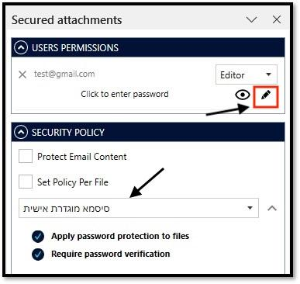

Open Password-Protected File
When the email reaches the recipient’s inbox, the recipient must click the link. A window will then open prompting the recipient to enter the password.
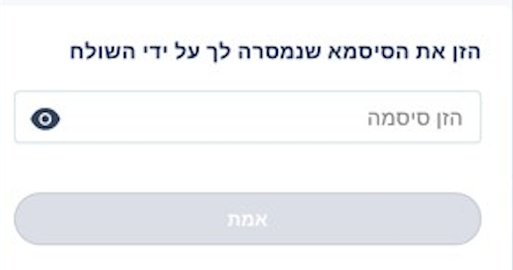
After the user completes the authentication process, they will be able to download the file.
When the recipient attempts to open the file on their personal computer, a window will appear prompting them to enter the password defined by the sender.
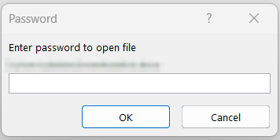
After entering the password, the user will be able to view the file!
If at any point you need assistance, our team is always glad to help.
Find us at: support@specterx.com

